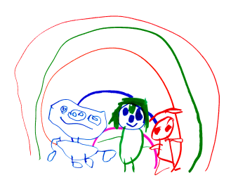
Cambridge Nursery School

COMMUNICATION & LANGUAGE

Using a core of twenty books and props – children build a knowledge of familiar text which has been planned to meet the levels of language in each room and also to address any gaps in knowledge

Why twenty books? - to expose children to maximum vocabulary and experience. Children need 250 words by the age of 2 years and children need 450 by age of 4 years to develop good base for language development.
Books include non- fiction rhyme, reference etc
These books are reviewed every year to reflect needs of current cohorts and ensure curriculum is bespoke
We strive to foster a love of books, reading and learning.

What this looks like in 2/3 year old class.

Story and song of the week
Songs and rhymes are ordered with basic traditional songs.
The journey is planned to allow progression and we use lots of resources to support this – story and song bags/dice, lots of visual opportunities
We are currently working to provide more props for the outside area.

3-4 year old class
Key carer time utilised to share books. We have props in the reading area to support the 20 books , additional books and resources are changed on a rota or depending on interests.
We use of URLEY tools i.e TROLL (teacher related oral language and literacy skills) to identify different levels and language styles i.e reluctant communicators.
This information is used to identify children that need to be targeted during continuous provision.

In both rooms we use ECCER’s SSTEW to audit provision and strengthen the use of continuous provision to reinforce learning across the curriculum. In observation and in our practice we use the ‘teaching words’ to extend vocabulary and teaching and learning i.e model, explain, comment, reflect, encourage.

Planning in both rooms is in the moment to allow the staff to scaffold the children’s learning and ensure a language rich environment.
Staff interactions is key – our staff are the vehicles to allow the conversations, interactions and reflections to happen.
Through play children gain the most valuable and high quality learning experiences.
Both rooms have small world in most areas and well equipped home corners to encourage role play, re-enactment of stories and storytelling.

We work with speech therapists to deliver bespoke speech and language interventions for identified children. We also have a range of bilingual books and a talking pen to support children with English as an additional language.

Staff remained trained and act as language leads to support other settings across local authorities.

This policy will be reviewed at least annually . Date of next review October 2024.

