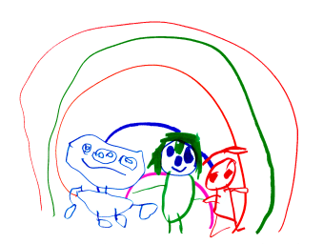
Cambridge Nursery School
LITERACY

At Cambridge we use a base of twenty books and props to help foster a lifelong love of reading. We use a variety of texts to expand and enhance the children's knowledge.
The twenty books are then enhanced with additional texts depending on the children's interests and needs. Some texts are repeated from 2/3 to 3/4 rooms to build on their knowledge. i.e. traditional tales such as the Three little pigs. Text will be carefully selected to ensure they are available at different levels.
Small world opportunities and role play to encourage story telling.
We will also act as story scribes to model a link between their gained knowledge and the purpose of written language.

Through in the moment planning adults will talk about the world around them in a meanful way to extend children’s knowledge.

- Songs and rhythms and poems are shared to develop intonation and tempo needed to develop children who are confident in literacy.

- Storytelling and books are available in all areas, indoors and outdoors, to encourage children to develop a love of stories and early comprehension skills, for example, talking about pictures and explaining unfamiliar words to develop understanding.

- Toddler talk (Eklclan) is used within our 2/3 year old provision to support language development. This then progresses to letters and sounds phase 1 and then Read, Write Inc is introduced in the summer term within nursery (see letters and sounds policy) for children who are developmentally ready.

To provide the children with an equal opportunity to share books at home we operate a lending library and provide the children with a book bag. A reward system recognises the number of books they borrow and return and begins the journey of valuing a commitment to reading at home as well as school. Our aim is to establish a routine which will follow them to Primary school.

Writing:

Opportunities for writing are plentiful. All areas are provided with a variety of resources to support the children to develop early writing skills. The motivation and purpose for writing is fuelled by the children’s interests and needs.
For example: filling in forms, making lists, mark making in mud, painting with water, dragging streamers through puddles. This links to gross and fine motor skills (see physical development).

This policy will be reviewed October 2024 or before if a need arises.

