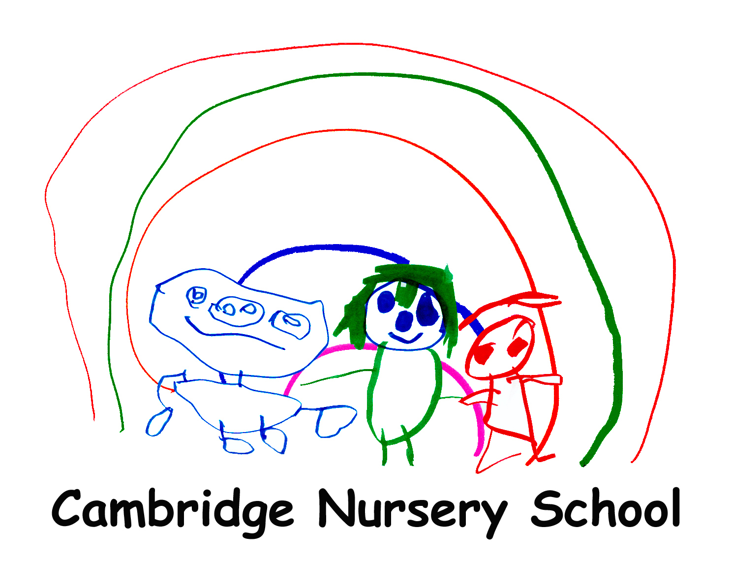

Teaching Phonics in our Nursery
Letters and Sounds
From September Letters and Sounds is integrated into our school day. Children have regular opportunities to access activities linked to first six aspects of the first phase of the DfE phonics programme. They are broken down as follows:
Aspect 1: Environmental sounds.
Adults help pupils to tune into sounds in our environment. This could include hearing an ambulance siren or birds singing while playing in the garden, or hearing the hand dryer or chair scraping on the floor while playing in class. Pupils will play games such as guess what has been hidden in a shaker (e.g. rice, feathers, dice) or behind a screen (e.g. keys, crisp packet, scissors).
Aspect 2: Instrumental sounds.
Pupils have access to musical instruments during their free play indoors and out. Adults encourage children to experiment with different ways to make sounds and model playing loudly and quietly, slowly and quickly.
Aspect 3: Body percussion.
Daily action rhymes provide children with an opportunity to hear and copy rhythms. Outdoors pupils will explore different ways of making sounds with their bodies.
Aspect 4: Rhythm and rhyme.
Pupils experience a wealth of songs and rhymes which pupils will hear repeatedly. Adults share rhymes and songs throughout the school day, for instance, if there is a spider in the garden they will model singing “Incy, wincy spider”. In the water tray they might sing 1,2,3,4,5 once I caught a fish alive”. Adults will also model making up nonsense rhymes, for instance by playing with children’s names. Adults share stories with lots of rhymes such as “Bear on the Stair”.

Aspect 5: Alliteration.
Adults model the playful use of alliteration while working with children. They might make a delicious dinner in the home corner, or a perfect pizza on the playdough table. There are lots of opportunities to listen to stories including alliteration such as “Pass the Jam, Jim”.
Aspect 6: Voice sounds.
Adults model vocalisations during children’s play. For instance a car might race around a track while an adult says “brmmm”. When watering plants an adult will model the “pshhh” sound of running water. Children are encouraged to join in and experiment with their own voice sounds. Children are encouraged to use their voice sounds to enliven stories, for instance by joining in with animal sounds or environmental sounds in stories such as Peace at Last.
Summer term
Aspect 7: Oral blending and segmenting.
Adults will segment and blend words at the end of a sentence. An adult might say Where is your c-oa-t? Do you need to wear a h-a-t? Listen to the b-ir-d. Turn on the t-a-p. Emphasis is placed on using pure sounds e.g. sssss, not adding an ending such as suh.
Challenging more able pupils
Phase 2: Teaching a letter.
A number of pupils will participate in discreet phonics lessons to learn letter sounds. The lessons will follow the Read Write Inc. programme. This is because the majority of our pupils go to schools which use this therefore the pupils will benefit from following the same system.

