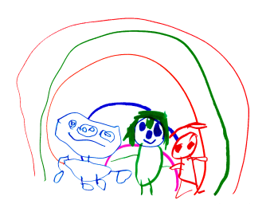

MATHEMATICS
At Cambridge we recognise that number is essential in developing a deep understanding of mathematical concepts. We recognise the importance of a ‘can do’ attitude and provide a variety of opportunities to have a go at mathematics and not be afraid to make mistakes. Mathematical opportunities saturate our environment and practice. Practitioners model the use of mathematical language including, time, space, measure, shape, positional language and pattern.

Staff and children will celebrate success and achievements from which a mastery of mathematics will be born,

Examples of how we do this: -

- Making patterns with flowers and leaves

- Observing patterns in everyday nature

- Measuring our sunflowers we have grown

- Counting

- Numbers songs

- Filling and emptying bottles

- Building with a variety of shapes and materials

This list is not exhaustive and we will strive to build of the children's interest and knowledge to revisit and consolidate concepts.

The policy will be reviewed annually. Date of next review June 2022.

