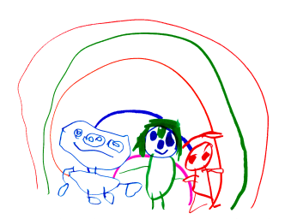

Personal Social and Emotional development.

Emotional wellbeing is the driving force for all our practice.

Routines are formed to support wellbeing and learning.

We ensure there are opportunities for children who may need adjustments or alternatives to ensure they feel secure, happy and able to learn.
Without high levels of wellbeing high levels of involvement won’t be achieved.
As professor Dr Ferre Laevers believes when children have high levels of well being they will display the following; Children in a state of well-being feel like 'fish in water'. The prevailing mood in their lives is Pleasure: they have fun, enjoy each other's company and feel o.k. in their environments.

All children have an identified key carer from day one. A strong, warm and supportive relationship is built with the family allowing the children to feel safe and secure.

What does this look like in practice?
- We use SSTEW(sustained shared thinking and emotional well being )scales to assess interactions and improve our practice
- Invest time and improve relationships in bespoke settling in, including ‘All about me’ documents which are completed, 1:1 supported visits, home visits, zooms, progress meetings, sharing of learning journeys, phone calls, school spider app, tapestry.

We understand the importance of children recognising their emotions and their characteristics of effective learning.

We use the capability resources to support the C. of E.L.
i.e. Cooper the crab – says focus and concentration see our website for more information.

We also label our emotions in practice
i.e. I’m happy when I build in the sand
I know you are frustrated because you want the spider man toy.
This leads to developing resilience and the ability to self-regulate our emotions.

We encourage a knowledge of our bodies and healthy eating. We do this through snack, physical movement and the effect on our bodies. We promote independence through personal care i.e. hand washing, toileting, putting on a coat.

We challenge the children to know what appropriate clothing is needed i.e. do you need wellies today?

We encourage a sense belonging in our school community by encouraging the skills required to form friendships and resolve conflicts. This is mirrored through the respectful staff interactions with parents.

This policy will be reviewed annually. Date of next review June 2022.

