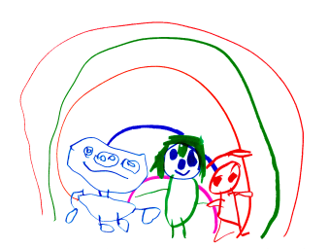
Cambridge Nursery School

PLANNING AND ASSESSMENT POLICY

In our nursery we use the approach of ‘In the moment planning’

How does this work?

We spend time getting to know the children, by this we mean observing, talking to their families, interacting with the child and this helps us build a picture of their stage of development.
Skilful and knowledgeable practitioners then can support the children through teachable moments, for example, a child playing in the sand is supported to put a funnel in a bottle.
A child playing with the trains is introduced to simple addition and subtraction with the train carriages. A child might be encouraged to sit down to eat snack. These examples are to highlight how in planning our curriculum we take into account the individual needs of each child.

Every term each child will have one or two focus weeks, children with identified additional needs will be focus children every week.

A pro-forma will be sent home the week before to identify interests and areas for development and give parents the opportunity to ask about their child’s development.

Parent’s/carers will then receive a phone call the week after to update them. These half term calls are our ' parent’s evenings'. We have an open door policy and staff will always make time to speak to parents. These calls are formally recognising children’s progress and areas for development.

The nursery uses ‘Tapestry’ to record observations and links to development matters for all the children. A snapshot of the children’s level of development is taken after two weeks from their start.

Data will be collected October half term, January and April. The purpose of data collection and scrutiny is to ensure that the curriculum is meeting the heads of all of the children. Any identified areas are addressed in the bespoke curriculum.

Learning journeys
This is a scrapbook/collection, a story of their time in nursery, a special place to document their time with us.

Feedback to parents
This happens both formally and informally.
Formally through the three parents feedback meetings, a 2 year check, a term after the child starts in the 2’s room and the end of year report in the 3 year old room.
Informally through our daily contact and sharing information on our website and social media channels of Facebook and Twitter.

This policy is reviewed yearly or before if a need is identified. Policy due to be reviewed October 2024.

